UNIVERSITY OF JAMMU
BHADERWAH CAMPUS


BACHELOR OF COMPUTER APPLICATION
(BCA-1ST SEMESTER)
PRACTICAL FILE
PROBLEM SOLVING USING C

SUBMITTED BY:
Suryansh Sharma
113040010
ACKNOWLEDGEMENT

I would like to express my gratitude to all those people who helped me to complete this practical file. I want to thank Department of computer science and IT for providing me all the tools and resources for the completion of my practical file.
I have further more to thank our respected teacher Mr. Abhay Khajuria who encouraged me to move ahead and complete my work in time. I am also bound to our Assistant Programmer Mr. Parvesh Singh whose help, simulating suggestions and encouragement helped me all the time during my work.
At last, I want to thank my classmates and friends for their help, support, interest and valuable hints. I want to thank once again all the above mentioned persons for their time and help.
Thank you.

Suryansh Sharma BCA 1st Semester
113040010

CERTIFICATE

This is to certify that Suryansh Sharma student of BCA-1stsemester, Session 2025-2028 bearing university Roll no. 113040010 has completed the required number of practical problems of Problem solving using C under the guidance of class teacher Mr. Abhay khajuria from the Department of Computer science and IT, Bhaderwah campus, University of Jammu.

Signature. Signature.
(I/C course coordinator) (Practical I/C)
Index 1/2
No. | Contents
1 | WAP to print Fibonacci series.
2 | WAP to check prime number.
3 | WAP to check palindrome number.
4 | WAP to print factorial of a number.
5 | WAP to print sum of digits.
6 | WAP to reverse given number.
7 | WAP to swap two numbers without using third variable.
8 | WAP to find average of n numbers.
9 | WAP to checking for odd and even numbers using bitwise operators.
10 | WAP to find factors of a number.
11 | WAP to find the largest number among n input numbers.
12 | WAP to check if input number is int or float.
13 | WAP to Multiply two floating-point numbers.
14 | WAP to find the size of int, float, double and char.
15 | WAP to find simple interest.
16 | WAP to find compound interest.
17 | WAP to find area and perimeter of rectangle.
18 | WAP to print prime numbers from 1 to N.
19 | WAP to find characters is vowel or not.
20 | WAP to find sum of complex numbers
21 | WAP to check whether the number is Armstrong or not.
22 | WAP to display Armstrong number between 1-1000.
23 | WAP to display half pyramid.
24 | WAP to display full pyramid
25 | WAP to check prime number by creating a function
26 | WAP to display prime number functions and for loop
27 | WAP to check whether a number can be expressed as sun of two prime numbers.
28 | WAP to find the sum of natural numbers using recursion
29 | WAP to calculate the factorial of a number using recursion

Index 2/2

30 | WAP to find GCD or HCF of two numbers
31 | WAP to calculate the power of a number
32 | WAP to find the largest number in an array
33 | WAP to calculate average of all elements of an array
34 | WAP to find common array elements between two array
35 | WAP to copy all the elements of one array to another
36 | WAP to find the determinant of 2x2 matrix
37 | WAP to read the matrix and sum the matrix.
38 | WAP to read the matrix and product of the matrix.
39 | WAP to find the sum of all elements in each row
40 | WAP to read the matrix and print its diagonal
41 | WAP to display the sum of two matrix
42 | WAP to display the subtraction of two matrix
43 | WAP to display the multiplication of two matrix
44 | WAP to check whether the two matrix are identical or not
45 | WAP to interchange the rows of a matrix.

WAP to print Fibonacci series.
#include<stdio.h>
void main()
{
// declearing variables
int a,b;
int n1=0, n2=1;
int nxtterm=n1+n2;
printf("Enter the value.\n");
scanf("%d",&a);
printf("Fabonacci series : %d, %d,",n1,n2);
for(b=3;b<=a;b++)
{
printf("%d,\n",nxtterm);
n1=n2;
n2=nxtterm;
nxtterm=n1+n2;
}
}

Output:-

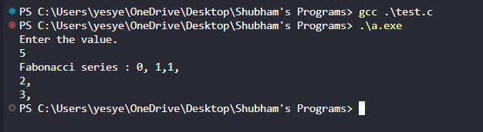

WAP to check Prime numbers.
#include<stdio.h>
void main()
{
int a,b,c=0;
printf("Enter the value.\n ");
scanf("%d",&a);
if (a==0 || a==1)
c=1;
for(b=2;b<=a/2;b++)
{
if(a%b==0)
{
c=1;
break;
}
}
if(c==0)
printf("%d is a prime number.\n",a);
else
printf("%d is not a prime number.\n",a);
}

Output:-
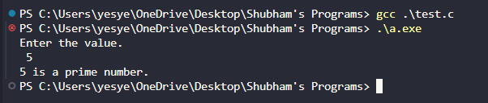
WAP to check Palindrome number.
#include<stdio.h>
void main()
{
long x,y,z,i=0;
printf("Enter the number :\n ");
scanf("%ld",&x);
z=x;
while(x>0)
{
y=x%10;
i=(i*10)+y;
x=x/10;
}
if(z==i)
printf("%ld is a palindrome number\n",z);
else
printf("%ld is not a palindrome number\n",z);
}
Output:-
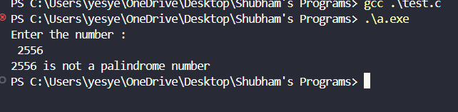

WAP to print Factorial of a number.
#include<stdio.h>
void main()
{
int a,b,c=1;
printf("Enter the value :\n");
scanf("%d", &a);
for(b=1;b<=a;b++)
{
c=c*b;
}
printf("Factorial of %d is : %d\n",a,c);
}

Output:-
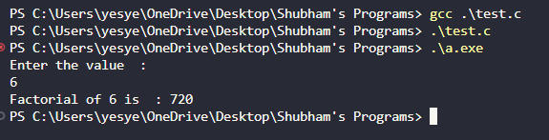
WAP to print sum of digits.
#include <stdio.h>
int main()
{
float n,num,sum,i;
i=0;
sum = 0;
printf("Enter number of elements : ");
scanf("%f",&n);
while(i<n){
i++;
printf("Enter number %.0f : ",i);
scanf("%f",&num);
sum+=num;
}
printf("The sum of numbers is : %.0f",sum);
return 0;
}

Output:-

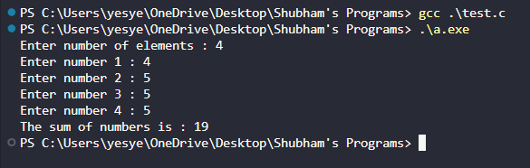
WAP to reverse given number.
#include<stdio.h>
int main()
{
long a,i=0 ,b;
printf("Enter the number :\n");
scanf("%ld",&a);
while (a!=0)
{
b=a%10;
i=i*10+b;
a/=10;
}
printf("Reversed number : %ld\n",i);
return 0;
}

Output:-
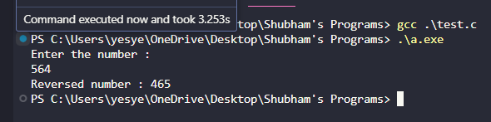

WAP to swap two numbers without using third variable.
#include<stdio.h>
void main()
{
int a;
int b;
printf("Enter the value of a :\n");
scanf("%d", &a);
printf("Enter the value of b :\n");
scanf("%d", &b);
a= a+b;
b= a-b;
a= a-b;
printf("the value of a= %d, \nthe value of b= %d\n", a,b);
}

Output:-
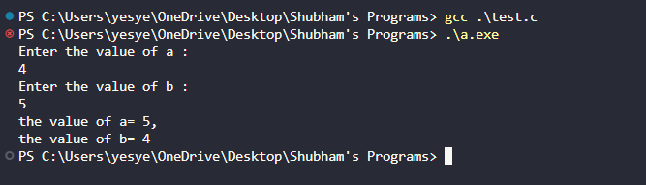

WAP to find average of n numbers.
#include<stdio.h>
void main()
{
int a,b;
float sum,avg;
printf("Enter the number of values :\n");
scanf("%d",&a);
printf("Enter the values :\n");
for (b=0;b<a;b++)
{
scanf("%f",&sum);
avg += sum;
}
avg=avg/a;
printf("the average of entered values is : %f\n",avg);
}

Output:-
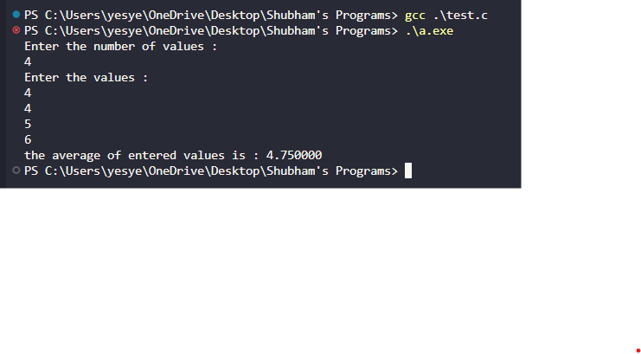

WAP to check for odd and even numbers using bitwise operator.
#include<stdio.h>
int main()
{
int num;
printf("Enter the no. : \n");
scanf("%d",&num);
if(num& 1)
{
printf("%d is odd.\n",num);
}
else
{
printf("%d is even.\n",num);
}
return 0;
}

Output:-
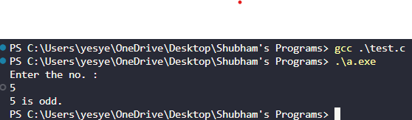

WAP to find factors of a number.
#include<stdio.h>
void main()
{
int n,i;
printf("Enter the value :\n ");
scanf("%d",&n);
printf("Factors of %d are :\n ",n);
for(i=1; i<=n; i++)
{
if(n%i == 0)
{
printf("%d ",i);
}
}
}

Output:-
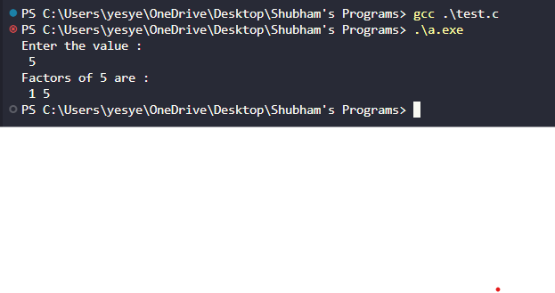

WAP to find the largest number among n input numbers.
#include<stdio.h>
void main()
{
int n,i;
int b,c;
printf("Enter the no. of values:\n");
scanf("%d",&n);
printf("enter %d no. : \n",n);
printf("value 1 : \n");
scanf("%d",&b);
for(i=2;i<=n;i++)
{
printf(“tvalue %d : \n",i);
scanf("%d",&c);
if(b<c)
b=c;
}
printf("the largest of these %d no. is %d\n",n,b);
}
Output:-

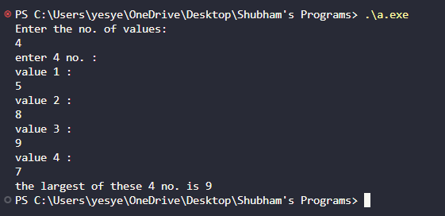

WAP to check if input number is int or float.
#include<stdio.h>
void main()
{
float a;
printf("Enter the number :\n");
scanf("%f",&a);
if(a==(int)a)
{
printf("The number is an integer.\n");
}
else {
printf("The number is a float.\n");
}
}

Output:-
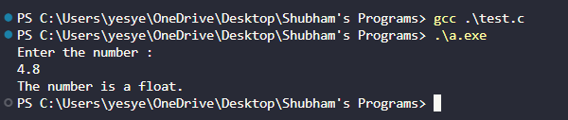

WAP to multiply two floating-point numbers.
#include<stdio.h>
int main()
{
double a,b,product;
printf("Enter the values :\n");
scanf("%lf %lf",&a,&b);
product=a*b;
printf("product=%.2lf\n",product);
return 0;
}

Output:-
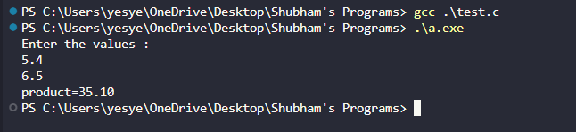

WAP to find the size of int, float, double and char.
#include<stdio.h>
void main()
{
int i;
float f;
double d;
char c;
printf("Size of int: %ld bytes\n",sizeof(i));
printf("Size of float: %ld bytes\n",sizeof(f));
printf("Size of double: %ld bytes\n",sizeof(d));
printf("Size of char: %ld bytes\n",sizeof(c));
}

Output:-
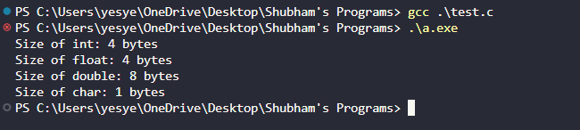

WAP to find simple interest.
#include<stdio.h>
int main()
{
float principal,rate,time,simpleInterest;
printf("Enter the Principal:\n");
scanf("%f",&principal);
printf("Enter the Rate of Interest:\n");
scanf("%f",&rate);
printf("Enter the Time(in years):\n");
scanf("%f",&time);
simpleInterest=(principal*rate*time)/100;
printf("Simple Interest is : %f\n",simpleInterest);
return 0;
}

Output:-
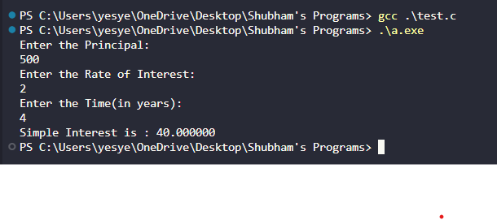

WAP to find compound interest.
#include<stdio.h>
#include<math.h>
int main()
{
float principal,rate,time,compoundInterest;
printf("Enter the Principal:\n");
scanf("%f",&principal);
printf("Enter the Rate of Interest:\n");
scanf("%f",&rate);
printf("Enter the Time(in years):\n");
scanf("%f",&time);
compoundInterest= principal* ((pow((1+rate/100),time)))-principal;
printf("Compound Interest is: %f\n",compoundInterest);
return 0;
}

Output:-
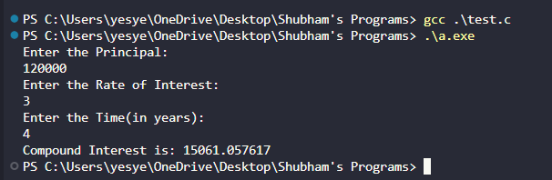

WAP to find area and perimeter of rectangle.
#include<stdio.h>
void main()
{
int length,breadth,area,perimeter;
printf("Enter the length of the rectangle:\n");
scanf(" %d",&length);
printf("Enter the breadth of the rectangle:\n");
scanf(" %d",&breadth);
area= length*breadth;
perimeter= 2*(length+breadth);
printf("The perimeter of the rectangle is %d\n",perimeter);
printf("\nThe area of the rectangle is %d\n",area);
}

Output:-
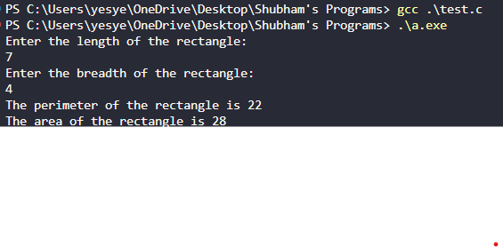

WAP to print prime numbers from 1 to n.
#include<stdio.h>
void main()
{
int n,i,c,j;
printf("Enter a number :\n");
scanf("%d",&n);
printf("Prime numbers between 1 and %d are : \n",n);
for(i=2;i<=n;i++)
{
c=0;
for(j=2;j<=i/2;j++)
{
if(i%j==0)
{
c++;
break;
}
}
if(c==0)
{
printf(" %d",i); }
}
}
Output:-
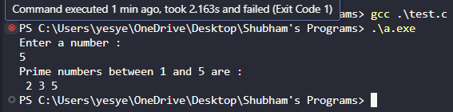

WAP to find character is vowel or not.
#include<stdio.h>
void main()
{
char ch;
printf("Enetr the character:\n");
scanf("%c", &ch);
if(ch=='a' || ch=='e' || ch=='i' || ch=='o' || ch=='u'||
ch=='A' || ch=='E' || ch=='I' || ch=='O' || ch=='U')
{
printf("%c is a vowel.\n",ch);
}
else{
printf("\n%c is a consonent.\n",ch);
}
}

Output:-
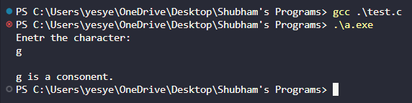

WAP to add two complex numbers.
#include<stdio.h>
typedef struct complex{
float real;
float img;
}
struct complex add(struct complex x, struct complex y){
struct complex add;
add.real=x.real+y.real;
add.img=x.img+y.img;
return add;
}
int main(){
struct complex a, b, sum;
printf("For 1st complex number. \n");
printf("Enter the real and imaginary parts : \n");
scanf("%f %f",&a.real,&a.img);
printf("\nFor 2nd complex number:\n");
printf("\nEnter the real and imaginary part:\n");
scanf("%f %f",&b.real,&b.img);
sum= add(a, b);
printf("\nsum = %f + %fi\n",sum.real,sum.img);
return 0;
}

Output:-
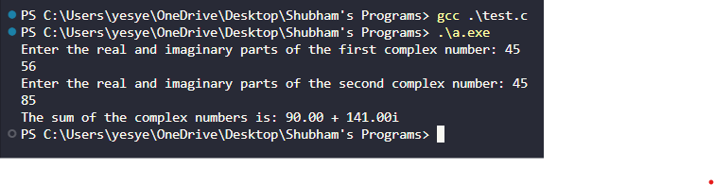
WAP to check whether the number is Armstrong or not.
#include <stdio.h>
#include <math.h>

int main() {
int num, originalNum, remainder, n = 0;
double result = 0.0;

printf("Enter an integer: ");
scanf("%d", &num);

originalNum = num;

while (originalNum != 0) {
originalNum /= 10;
++n;
}

originalNum = num;

while (originalNum != 0) {
remainder = originalNum % 10;
result += pow(remainder, n);
originalNum /= 10;
}

if ((int)result == num)
printf("%d is an Armstrong number.\n", num);
else
printf("%d is not an Armstrong number.\n", num);

return 0;
}
Output:-
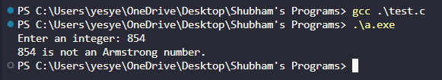
WAP to display the Armstrong numbers between 1 to 1000.
#include<stdio.h>
void main()
{
int n,i,k,sum=0;
printf("The armstrong numbers between 1 and 1000 are :\n");
for(i=1;i<=1000;i++) {
sum=0;
k=i;
while(k>0){
n=k%10;
sum+=n*n*n;
k/=10;
}
if(sum==i){
printf(" %d",i);
}
}
}

Output:-
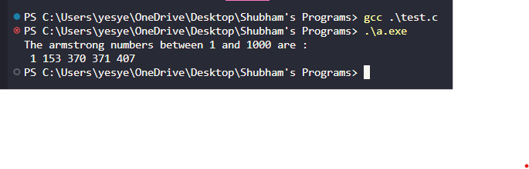
WAP to display half pyramid.
#include <stdio.h>

int main() {
int rows, i, j;

printf("Enter the number of rows: ");
scanf("%d", &rows);

for (i = 1; i<= rows; i++) {
for (j = 1; j <= i; j++) {
printf("* ");
}
printf("\n");
}

return 0;
}
Output:-
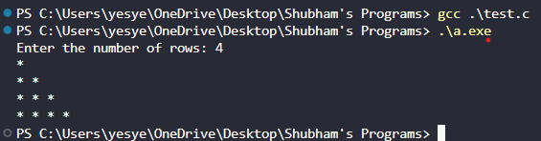
WAP to display full pyramid.
#include <stdio.h>

int main() {
int rows, i, j, space;

printf("Enter the number of rows: ");
scanf("%d", &rows);

for (i = 1; i<= rows; i++) {
for (space = 1; space <= rows - i; space++) {
printf(" ");
}
for (j = 1; j <= 2 * i - 1; j++) {
printf("* ");
}
printf("\n");
}

return 0;
}
Output:-
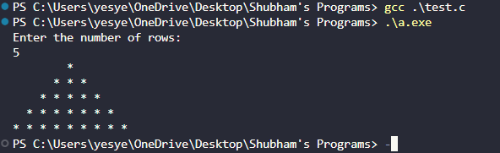

WAP to check prime number by creating a function.
#include<stdio.h>
int primenumber(int n)
{
int a;
for(a=2;a<=n/2;a++)
{
if(n%a!=0)
continue;
else
return 1;
}
return 0;
}
void main()
{
int i,f=0;
printf("Enter the number :\n");
scanf("%d",&i);
f=primenumber(i);
if(f==0)
printf("%d is a prime number.\n",i);
else
printf("%d is not a prime number.\n",i);
}
Output:-
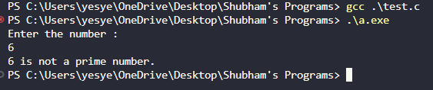

WAP to display prime numbers between two intervals using functions and for loop.
#include<stdio.h>
int checkprimenumber(int n)
{
int a,b=1;
for(a=2;a<=n/2;a++)
{
if(n%a==0) {
b=0;
break;
}
}
return b;
}
void main()
{
int n1,n2,c,b;
printf("Enter the values :\n");
scanf("%d %d",&n1,&n2);
printf("The prime numbers between %d and %d are :\n",n1,n2);
for(c=n1;c<n2;c++)
{
b=checkprimenumber(c);
if(b==1)
{
printf(" %d",c);
}
}
}

Output:-
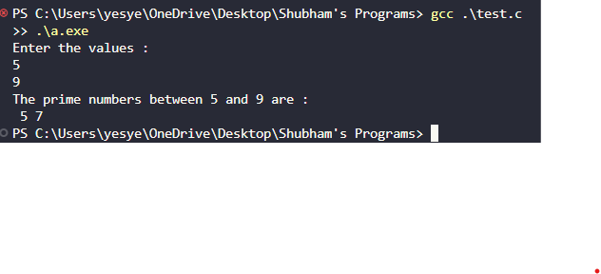
WAP to check whether a number can be expressed as sum of two prime numbers.
#include<stdio.h>
int checkprime(int n);
void main()
{
int n,i,x=0;
printf("Enter the number :\n");
scanf("%d",&n);
for(i=2;i<=n/2;i++)
{
if(checkprime(i)==1)
{
if(checkprime(n-i)==1)
{
printf("%d = %d + %d\n",n,i,n-i);
x=1;
}
}
}
if(x==0)
printf("%d cannot be expressed as the sum of two prime numbers.\n",n);
}
int checkprime(int n)
{
int i,b=1;
if(n==0 || n==1)
{
b=0;
}
else
{
for(i=2;i<=n/2;i++)
{
if(n%i==0)
{
b=0;
break;
}
}
}
return b;
}

Output:-
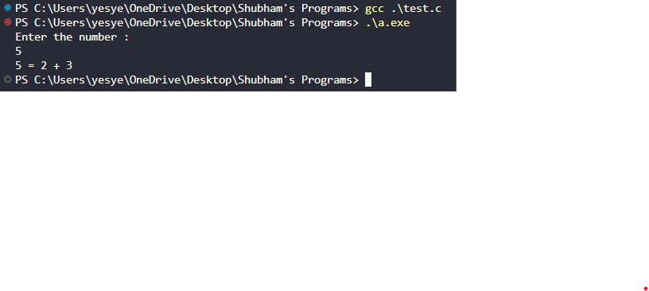

WAP to find sum of natural numbers using recursion.
#include<stdio.h>
int addnumbers(int n)
{
if(n!=0)
return n + addnumbers(n-1);
else
return n;
}
void main()
{
int x;
printf("Enter the number of values :\n");
scanf("%d",&x);
printf("Sum = %d\n",addnumbers(x));
}

Output:-
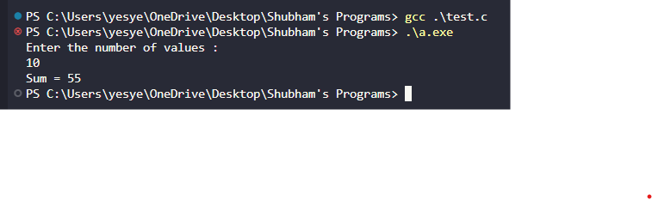
WAP to calculate the factorial of a number using recursion.
#include<stdio.h>
long int mtlpnumbers(int n)
{
if(n>=1)
return n*mtlpnumbers(n-1);
else
return 1;
}
void main()
{
int n;
printf("Enter the number :\n");
scanf("%d",&n);
printf("Factorial of %d is %ld.\n",n,mtlpnumbers(n));
}

Output:-
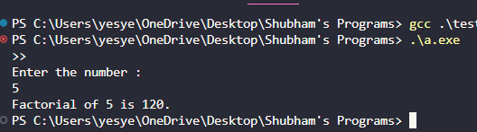
WAP to find the GCD or HCF of two numbers.
#include<stdio.h>
void main()
{
int a,b,c,gcd;
printf("Enter the two values :\n");
scanf("%d %d",&a,&b);
for(c=1;c<=a && c<=b;c++)
{
if(a%c==0 &&b%c==0)
gcd=c;
}
printf("G.C.D of %d and %d is %d\n",a,b,gcd);
}

Output:-
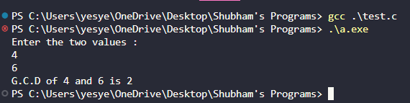
WAP to calculate the power of a number.
#include<stdio.h>
#include<math.h>
void main()
{
int n,x,s;
printf("Enter the number and its power.\n: ");
scanf("%d %d",&n,&x);
s=pow(n,x);
printf("(%d)^%d=%d\n",n,x,s);
}

Output:-
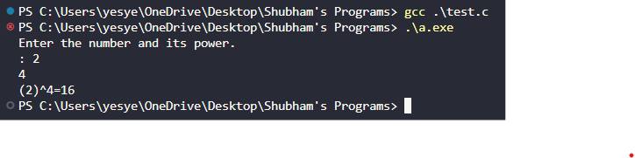
WAP to find the largest number in an array.
#include<stdio.h>
void main()
{
int i;
long int x;
long int arr[10000];
printf("Enter the number of elements :\n");
scanf("%ld",&x);
for(i=0;i<x;i++)
{
printf("Enter number %d :\n",i+1);
scanf("%ld",&arr[i]);
}
for(i=1;i<x;i++)
{
if(arr[0]<arr[i])
{
arr[0]=arr[i];
}
}
printf("Largest element = %ld\n",arr[0]);
}

Output:-
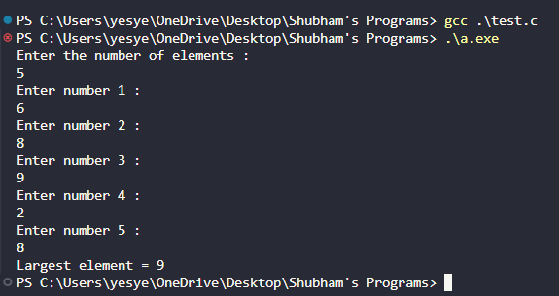
WAP to calculate average of all elements of an array.
#include<stdio.h>
void main()
{
long int z,i;
long int a[10000];
float avrg,p=0.0;
printf("Enter the numbers of elements :\n");
scanf("%ld",&z);
for(i=0;i<z;i++)
{
printf("%ld. Enter the number :\n",i+1);
scanf("%ld",&a[i]);
p+=a[i];
}
avrg=p/z;
printf("Average = %f\n",avrg);
}

Output:-
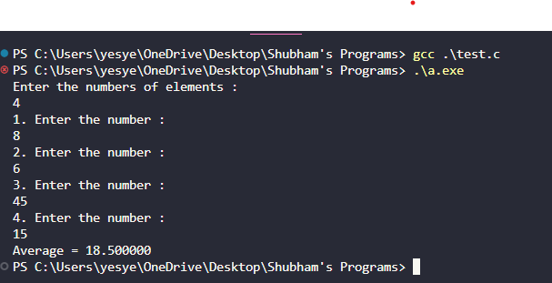
WAP to find common array elements between two arrays.
#include<stdio.h>
void main()
{
int a1[100],a2[100],a,b,la1,la2;
int i,j,bool,x,k=0;
int a3[100];
printf("Enter the number of elements for array 1 :\n");
scanf("%d",&a);
for(la1=0;la1<a;la1++)
{
printf("Enter the element %d :\n",la1+1);
scanf("%d",&a1[la1]);
}
printf("Enter the number of elements for array 2 :\n");
scanf("%d",&b);
for(la2=0;la2<b;la2++)
{
printf("Enter the element %d :\n",la2+1);
scanf("%d",&a2[la2]);
}
printf("\n\nElements of array 1 : ");
for(la1=0;la1<a;la1++)
{
printf(" %d\n",a1[la1]);
}
printf("\nElements of array 2 : \n");
for(la2=0;la2<b;la2++)
{
printf(" %d \n",a2[la2]);
}
printf("\nCommon elements between these two are :\n");
for(i=0;i<a;i++)
{
for(j=0;j<b;j++)
{
if(a1[i]==a2[j])
{
bool=0;
for(x=0;x<k;x++)
{
if(a3[x]==a1[i])
bool++;
}
if(bool==0)
{
a3[k]=a1[i];
k++;
}
}
}
}
for(i=0;i<k;i++)
{
printf(" %d",a3[i]);
}
}

Output:-
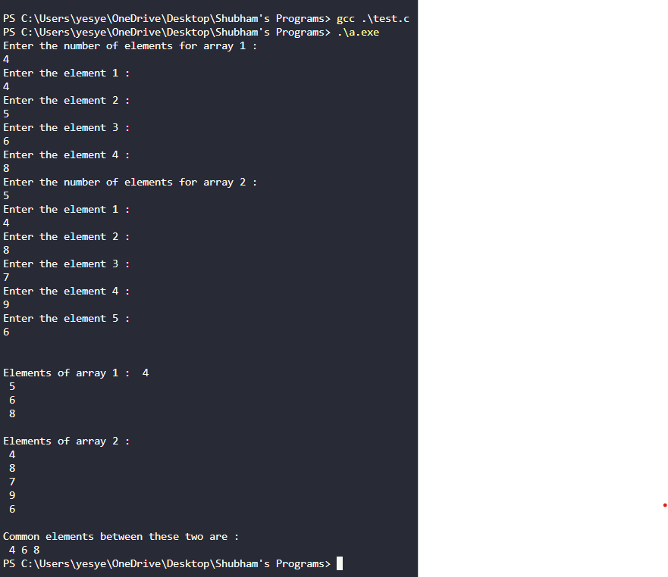
WAP to copy all the elements of one array to another.
#include<stdio.h>
void main()
{
int a1[100],a2[100],l,a;
printf("Enter the size of array :\n");
scanf("%d",&a);
for(l=0;l<a;l++)
{
printf("Enter the element %d : \n",l+1);
scanf("%d",&a1[l]);
a2[l]=a1[l];
}
printf("\nFirst array = ");
for(l=0;l<a;l++)
{
printf(" %d",a1[l]);
}
printf("\nAfter coping...\nSecond array = ");
for(l=0;l<a;l++)
{
printf(" %d",a2[l]);
}
}

Output:-
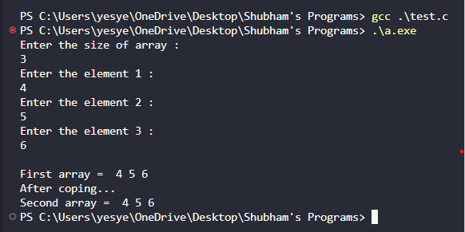
WAP to find determinant of 2x2 matrix.
#include<stdio.h>
void main()
{
long int a[2][2],l1,l2,ans;
printf("Enter the elements of the matrix : \n");
for(l1=0;l1<2;l1++)
for(l2=0;l2<2;l2++)
scanf("%ld",&a[l1][l2]);
printf("The entered matrix is : \n");
for(l1=0;l1<2;l1++)
{
for(l2=0;l2<2;l2++)
{
printf("%ld\t",a[l1][l2]);
}
printf("\n");
}
ans=a[0][0]*a[1][1] - a[1][0]*a[0][1];
printf("Determinent of this 2x2 matrix is : %ld - %ld = %ld\n",a[0][0]*a[1][1],a[1][0]*a[0][1],ans);
}

Output:-
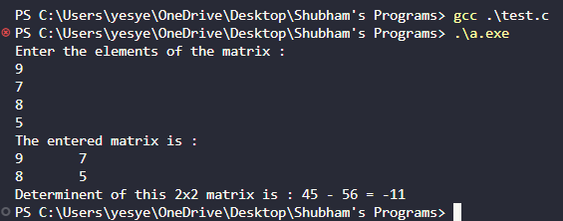
WAP to read the matrix and sum of the matrix.
#include<stdio.h>
void main()
{
int a,b,l1,l2,x=0;
int m[100][100];
printf("Enter the number of rows and columns of the matrix : \n");
scanf("%d %d",&a,&b);
m[a][b];
printf("\nEnter the elements of the matrix : \n");
for(l1=0;l1<a;l1++)
{
for(l2=0;l2<b;l2++)
{
printf("Enter element [%d,%d] : \n",l1+1,l2+1);
scanf("%d",&m[l1][l2]);
x+=m[l1][l2];
}
}
printf("The entered matrix is : \n");
for(l1=0;l1<a;l1++)
{
for(l2=0;l2<b;l2++)
{
printf("%d\t",m[l1][l2]);
}
printf("\n");
}
printf("\nThe sum of the matrix is : %d\n",x); }
Output:-
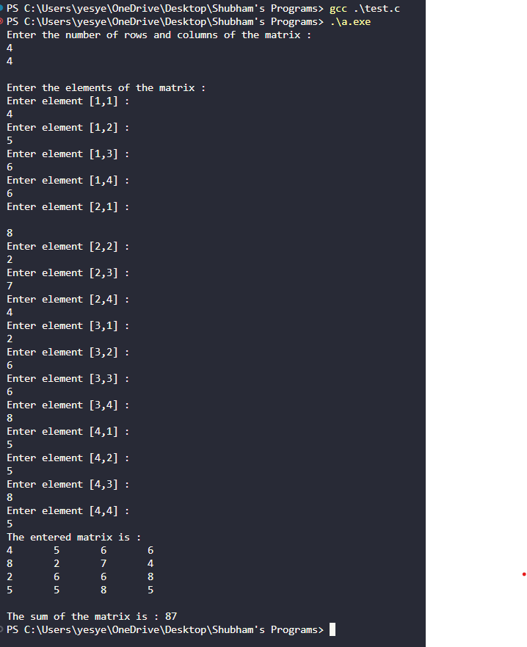
WAP to read the matrix and product of the matrix.
#include<stdio.h>
void main()
{
int a,b,l1,l2,p=1;
int m[100][100];
printf("Enter the number of rows and columns of the matrix :\n ");
scanf("%d %d",&a,&b);
m[a][b];
printf("\nEnter the elements of the matrix : \n");
for(l1=0;l1<a;l1++)
{
for(l2=0;l2<b;l2++)
{
printf("Enter element [%d,%d] : ",l1+1,l2+1);
scanf("%d",&m[l1][l2]);
p*=m[l1][l2];
}
}
printf("\nThe entered matrix is : \n");
for(l1=0;l1<a;l1++)
{
for(l2=0;l2<b;l2++)
{
printf("%d\t",m[l1][l2]);
}
printf("\n");
}
printf("\nThe product of the matrix is : %d\n",p); }
Output:-
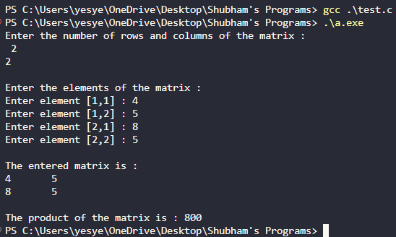

WAP to find the sum of all elements in each row.
#include<stdio.h>
void main()
{
int a,b,l1,l2,m[100][100],x;
printf("Enter the number of rows and columns of the matrix : \n");
scanf("%d %d",&a,&b);
m[a][b];
printf("Enter the elements of the matrix : \n");
for(l1=0;l1<a;l1++)
{
for(l2=0;l2<b;l2++)
{
scanf("%d",&m[l1][l2]);
}
}
printf("The matrix you entered : \n");
for(l1=0;l1<a;l1++)
{
for(l2=0;l2<b;l2++)
{
printf("%d\t",m[l1][l2]);
}
printf("\n");
}
for(l1=0;l1<a;l1++)
{
x=0;
for(l2=0;l2<b;l2++)
{
x=x+m[l1][l2];
}
printf("The sum of row %d is = %d\n",l1+1,x);
}
}

Output:-
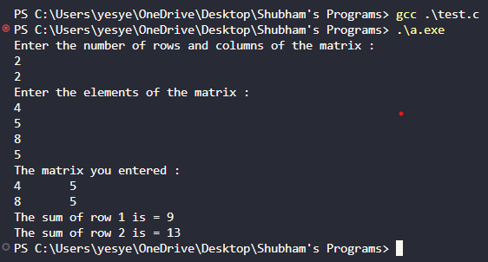
WAP to read the matrix and print its diagonals.
#include<stdio.h>
void main()
{
int a,b,l1,l2;
int m[100][100];
printf("Enter the number of rows and columns of the matrix :\n");
scanf("%d %d",&a,&b);
m[a][b];
printf("\nEnter the elements of the matrix : \n");
for(l1=0;l1<a;l1++)
{
for(l2=0;l2<b;l2++)
{
printf("Enter element [%d,%d] : ",l1+1,l2+1);
scanf("%d",&m[l1][l2]);
}
}
printf("The entered matrix is : \n");
for(l1=0;l1<a;l1++)
{
for(l2=0;l2<b;l2++)
{
printf("%d\t",m[l1][l2]);
}
printf("\n");
}
if(a==b)
{
printf("Diagonals of this matrix : \n");
for(l1=0;l1<b;l1++)
{
for(l2=0;l2<a;l2++)
{
if(l1==l2)
printf("%d\t",m[l2][l1]);
else
printf("\t");
}
printf("\n");
}
}
else
{
printf("\nMatrix is not a square matrix.\n");
}
}

Output:-
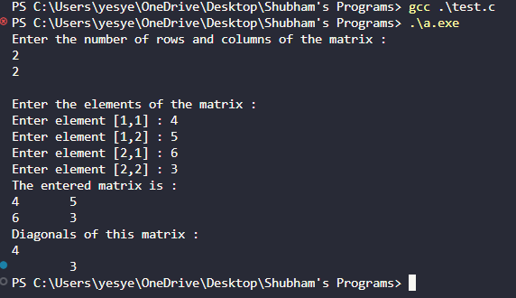
WAP to display the sum of two matrix.
#include<stdio.h>
void main()
{
int l1,l2,a,b;
int m1[100][100], m2[100][100], m3[100][100];
printf("Enter the size of the matrix : \n");
scanf("%d %d",&a,&b);
printf("\nEnter the elements of the 1st matrix : \n");
for(l1=0;l1<a;l1++)
{
for(l2=0;l2<b;l2++)
{
printf("Enter element [%d,%d] : ",l1+1,l2+1);
scanf("%d",&m1[l1][l2]);
}
}
printf("\nEnter the elements of the 2nd matrix : \n");
for(l1=0;l1<a;l1++)
{
for(l2=0;l2<b;l2++)
{
printf("Enter element [%d,%d] : ",l1+1,l2+1);
scanf("%d",&m2[l1][l2]);
m3[l1][l2]=m1[l1][l2]+m2[l1][l2];
}
}
printf("The 1st matrix is : \n");
for(l1=0;l1<a;l1++)
{
for(l2=0;l2<b;l2++)
{
printf("%d\t",m1[l1][l2]);
}
printf("\n");
}
printf("The 2nd matrix is : \n");
for(l1=0;l1<a;l1++)
{
for(l2=0;l2<b;l2++){
printf("%d\t",m2[l1][l2]);
}
printf("\n");
}
printf("The solution to the addition of these two matrix :\n");
for(l1=0;l1<a;l1++)
{
for(l2=0;l2<b;l2++)
{
printf("%d\t",m3[l1][l2]);
}
printf("\n");
}

}

Output:-
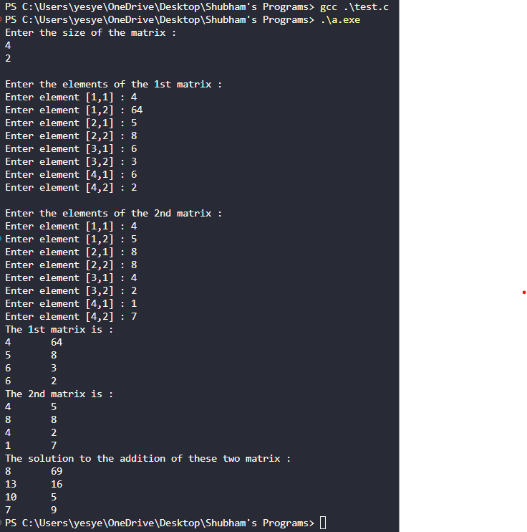
WAP to display the subtraction of two matrix.
#include<stdio.h>
void main()
{
int l1,l2,a,b;
int m1[100][100], m2[100][100], m3[100][100];
printf("Enter the size of the matrix :\n");
scanf("%d %d",&a,&b);
printf("\nEnter the elements of the 1st matrix : \n");
for(l1=0;l1<a;l1++)
{
for(l2=0;l2<b;l2++)
{
printf("Enter element [%d,%d] : ",l1+1,l2+1);
scanf("%d",&m1[l1][l2]);
}
}
printf("\nEnter the elements of the 2nd matrix : \n");
for(l1=0;l1<a;l1++)
{
for(l2=0;l2<b;l2++)
{
printf("Enter element [%d,%d] : ",l1+1,l2+1);
scanf("%d",&m2[l1][l2]);
m3[l1][l2]=m1[l1][l2]-m2[l1][l2];
}
}
printf("The 1st matrix is : \n");
for(l1=0;l1<a;l1++)
{
for(l2=0;l2<b;l2++)
{
printf("%d\t",m1[l1][l2]);
}
printf("\n");
}
printf("The 2nd matrix is : \n");
for(l1=0;l1<a;l1++)
{
for(l2=0;l2<b;l2++)
{
printf("%d\t",m2[l1][l2]);
}
printf("\n");
}
printf("The solution to the subtraction of these two matrix :\n");
for(l1=0;l1<a;l1++)
{
for(l2=0;l2<b;l2++)
{
printf("%d\t",m3[l1][l2]);
}
printf("\n");
}
}

Output:-
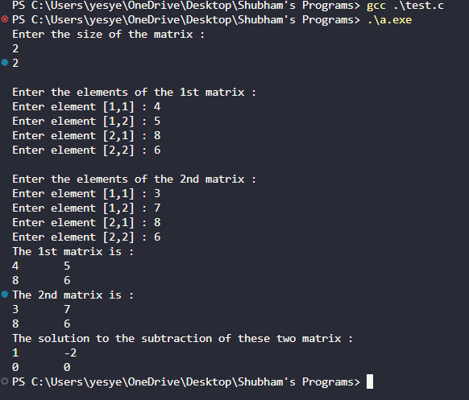
WAP to display the multiplication of two matrix.
#include<stdio.h>
void main()
{
int l1,l2,l3,a,b;
int m1[100][100], m2[100][100], m3[100][100];
printf("Enter the size of the matrix :\n");
scanf("%d %d",&a,&b);
printf("\nEnter the elements of the 1st matrix : \n");
for(l1=0;l1<a;l1++)
{
for(l2=0;l2<b;l2++)
{
printf("Enter element [%d,%d] : ",l1+1,l2+1);
scanf("%d",&m1[l1][l2]);
}
}
printf("\nEnter the elements of the 2nd matrix : \n");
for(l1=0;l1<a;l1++)
{
for(l2=0;l2<b;l2++)
{
printf("Enter element [%d,%d] : ",l1+1,l2+1);
scanf("%d",&m2[l1][l2]);
}
}
printf("The 1st matrix is : \n");
for(l1=0;l1<a;l1++)
{
for(l2=0;l2<b;l2++)
{
printf("%d\t",m1[l1][l2]);
}
printf("\n");
}
printf("The 2nd matrix is : \n");
for(l1=0;l1<a;l1++)
{
for(l2=0;l2<b;l2++)
{
printf("%d\t",m2[l1][l2]);
}
printf("\n");
}
printf("The product of these two matrix :\n");
for(l1=0;l1<a;l1++)
{
for(l2=0;l2<b;l2++)
{
m3[l1][l2]=0;
for(l3=0;l3<b;l3++)
{
m3[l1][l2]+=m1[l1][l3]*m2[l3][l2];
}
printf("%d\t",m3[l1][l2]);
}
printf("\n");
}}

Output:-
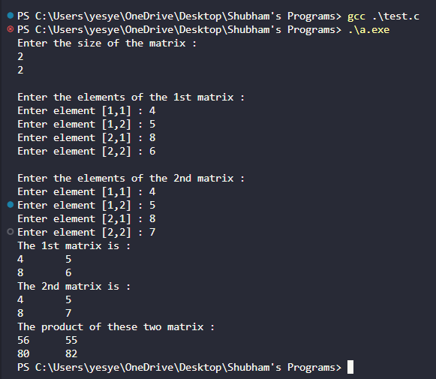
WAP to check whether the two matrix are identical or not.
#include<stdio.h>
void main()
{
int l1,l2,a,b, bool=1;
int m1[100][100], m2[100][100], m3[100][100];
printf("Enter the size of the matrix : \n");
scanf("%d %d",&a,&b);
printf("\nEnter the elements of the 1st matrix : \n");
for(l1=0;l1<a;l1++)
{
for(l2=0;l2<b;l2++)
{
printf("Enter element [%d,%d] : ",l1+1,l2+1);
scanf("%d",&m1[l1][l2]);
}
}
printf("\nEnter the elements of the 2nd matrix : \n");
for(l1=0;l1<a;l1++)
{
for(l2=0;l2<b;l2++)
{
printf("Enter element [%d,%d] : ",l1+1,l2+1);
scanf("%d",&m2[l1][l2]);
m3[l1][l2]=m1[l1][l2]+m2[l1][l2];
}
}
printf("The 1st matrix is : \n");
for(l1=0;l1<a;l1++)
{
for(l2=0;l2<b;l2++)
{
printf("%d\t",m1[l1][l2]);
}
printf("\n");
}
printf("The 2nd matrix is : \n");
for(l1=0;l1<a;l1++)
{
for(l2=0;l2<b;l2++)
{
printf("%d\t",m2[l1][l2]);
}
printf("\n");
}
for(l1=0;l1<a;l1++)
{
for(l2=0;l2<b;l2++)
{
if(m1[l1][l2] != m2[l1][l2])
{
bool=0;
break;
}
}
}
if(bool==1){
printf("The matrices are identical.\n");
}
else
{
printf("The matrices are not identical.\n");
}
}
Output:-
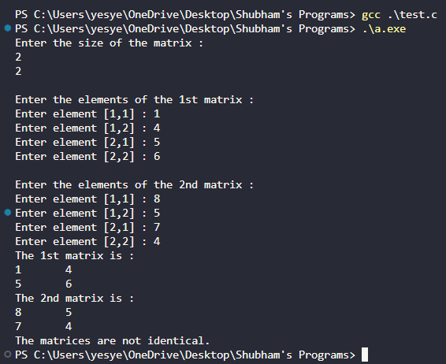

WAP to interchange the rows of a matrix.
#include<stdio.h>
void main()
{
int a,b,l1,l2,x;
int m[100][100],r1,r2;
printf("Enter the number of rows and columns of the matrix :\n");
scanf("%d %d",&a,&b);
m[a][b];
printf("\nEnter the elements of the matrix : \n");
for(l1=0;l1<a;l1++)
{
for(l2=0;l2<b;l2++)
{
printf("Enter element [%d,%d] : ",l1+1,l2+1);
scanf("%d",&m[l1][l2]);
x+=m[l1][l2];
}
}
printf("The entered matrix is : \n");
for(l1=0;l1<a;l1++)
{
for(l2=0;l2<b;l2++)
{
printf("%d\t",m[l1][l2]);
}
printf("\n");
}
printf("The rows to be interchanged : \n");
scanf("%d %d",&r1,&r2);
for(l1=0;l1<a;l1++)
{
x=m[r1-1][l1];
m[r1-1][l1]=m[r2-1][l1];
m[r2-1][l1]=x;
}
printf("\nMatrix after interchanging rows : \n");
for(l1=0;l1<a;l1++)
{
for(l2=0;l2<b;l2++){
printf("%d\t",m[l1][l2]);
}
printf("\n");
}
}

Output:-
